Science at Home

Not all of these activities will be ones you can do at home, it depends what you have at home, if you have a garden etc. But don’t worry, do the ones you can do, there is more than enough to keep you busy for a while!

Related to class topics:
By year group, though feel free to try another year group’s task if you think they look interesting.

Year 3/4 (Rocks):
- Rocks: Go out into the garden (if you have one) and see how many rocks and pebbles you can find – how could you describe them? Can you find ways to group similar ones?
- Fossils:
  - Make an animal from matchsticks, pipe cleaners, scrunched up tin foil, Lego (whatever you have to hand), then use playdoh, or make your own salt dough (roughly 2 parts flour to one part salt and enough water to bring it together) and squish it over your animal. Carefully peel it off and hey presto! You made a fossil.
  - Make chocolate fossils. Grate milk and white chocolate in separate bowls. Put a small toy animal, piece of Lego etc in the bottom of a small pot and line the whole thing with cling film. Start layering the grated chocolate over the top. Use a ball of cling film to push it all down. When you think you’ve squashed it hard enough – squash harder! Dipping it warm water will help. Leave to set. Turn out and peel back the cling film – your very own edible fossil.
- Soils:
  - Go into the garden and look at the soil in different parts of the garden, if you have a magnifying glass even better. What is the soil made up of?
  - If you have any seeds and pots, try growing plants in soil from different parts of the garden or mix some soil with different things eg. salt, rocks, sand. Which plants grow best? (Remember to make it a fair test you need to give them the same amount of water and keep them in the same place.)
- Erosion:

  - Watch this video https://www.youtube.com/watch?v=0PMsdoi-XP4
  - Try out the experiments yourself if you have any of the materials available.
  - Can you think of any real-life examples or erosion?

Year 5 (Properties and Changes of Materials):
- Properties of materials:
  - Test out different materials to see if they are soluble (they dissolve). The kitchen is a great place to find things to test but ask an adult first! Test out which things float. Test different material to see how waterproof they are – what would be best to make a coat from, why?
  - Design a superhero – what are their abilities? Now design a costume for you hero. What will the costume be made of and why? (If your hero can swim, then they might need something waterproof. What if they can fly or create fire etc.?)
- Separating: Try our rock candy lollies at home. Here is a recipe: https://www.thespruceeats.com/rock-candy-521016 but there are plenty of others if you google it. You will need an adult to make the syrup, which involves a hob and sugar that can get VERY hot. See what happens. Why is the sugar separating? You could see if different colours or flavouring affect how quickly the lollies form.
- Reversible and Irreversible Changes: Some changes in materials can be reversed (changed back) – think freezing water into ice and the melting to get water again. Others can’t – if I bake a cake or burn my toast, can I ever get the ingredients back to how they were to start with?
  - Make a list of all the reversible and irreversible changes you can think of (again the kitchen is a great place for this and a fab reason too go and help out who ever does the cooking in your house).
  - Make chocolates – melt some chocolate, pour into moulds and put it in the fridge. Your very own (yummy) reversible change!
  - Ask an adult if you have these ingredients and if they don’t mind you using them before you start. Add some bicarbonate of soda to vinegar – what happens? Do you think you could separate these things back out? You can play around with this one and see what happens if you change the amount of bicarb you put in.

Year 6 (Light):
- Shadows:
  - Go out into the garden at different times of the day. Photograph or draw your shadow (or the shadow of a teddy or something) from the same spot each time. What is happening to your shadow? What is changing to make this happen?
  - Make a blanket fort or find somewhere dark and take a torch with you. Make shadow animals with your hands, here are some ideas https://www.youtube.com/watch?v=Uv-MdaBfk8U, but see if you can make your own too. What happens to the size of the shadow if you move closer / further from the torch?
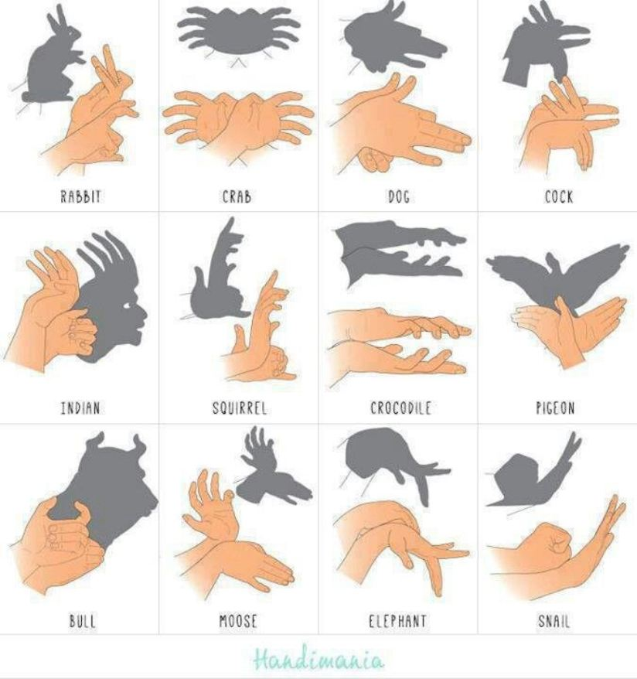

- Reflections:
  - Place two pieces of card vertically on pieces of blue tac. Shine the torch on one of the cards so that the light will be reflected on to the other card. Keep moving the card apart until you can no longer see the light reflected on the second card. You can measure this distance. Repeat this, but each time connects a different material to the first card. Which one reflected most light (moved furthest).
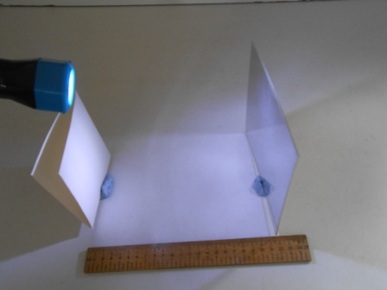

  - Play spies! If you can find a small mirror (a make-up mirror would work well), use it to try and see round corners – can you use it to look round the door into another room. See if you can do this without being spotted.
  - If you can find more than one mirror, set them up opposite each other and place a small toy in the middle. What is happening? If you change the angles of the mirrors, does it change how many reflections you can see? You may be able to do something similar if you have a mirrored bathroom cabinet.

- Rainbows: This one is clearly weather dependent! If it rains while the sun is out, look out of your window or go into the garden. Sunlight is made up of lots of colours but when they are together they seem white. The rain splits the colours up and makes a rainbow. Draw what you see, what order are the colours in? Look carefully, sometimes you can see a second, fainter rainbow next to the first one. Are the colours in the same order?
- Fun effect with light
  - Make some old-fashioned toys that rely on optical illusions.
  - Here is a video showing you how to make a phenakistoscope (don’t worry it took me ages to work out how to say it!) Don’t worry about getting the angles exact and you don’t have to have a separate small circle, you can draw on to the bigger one. If you do use two circles the Pritt Stick will do just fine. https://www.google.com/search?q=make+a+phenakistascope&rlz=1C1GCEA_enGB792GB792&oq=make+a+phenakistascope&aqs=chrome..69i57j0l3.6782j0j7&sourceid=chrome&ie=UTF-8#kpvalbx=_ZIl5XpXqH82igQaZj7LYBw41
  - Or you could try making a thaumatrope (again, don’t worry about how you say it). This one is a little easier. https://www.auntannie.com/FridayFun/MiniMovie/
  - Google optical illusion, there are loads of fun effects for you to explore.

Non-Topic Related Science Activities:

Projects /dairies:
- Watch the weather forecast each day. Now watch the weather, you could make a diary and draw the weather. How many times was the weather forecast right?
- Keep a moon diary. Go outside after dark each day and either photograph or draw what the moon looks like. Do you notice a difference? What is happening?
- If you have any seeds, grow a plant. Draw or photograph it every day or two to watch it grow. You could try more than one plant and put them in different places or give them different amounts of water – how does that affect how they grow?

Outside:
- Go out into the garden, what animals and bugs can you see (lift stones or branches, look high and low)? You could draw what you find and where they live? Why do you think that makes a good home for them?
- Use an online identifier to research any bugs and birds in your garden.
- Download an app that identifies things in the night sky, I have Sky Map, but there are loads to choose from. Go into your garden when it is dark and point the phone at the sky, it will tell you what you are looking at. Can you find the Pole Star/Polaris/North Star, or Venus, Mars or Jupiter? What constellations can you see?
- Measure your pulse while you are resting (you may need an adult to help you). Now go outside and jog around your garden a couple of times. Now measure your pulse again. Have a rest, then go back out and run around the garden as fast as you can the same number of times you did before. Measure you pulse again. What happened? Why do you think this happened? How did you feel after each activity?
- Look at the different plants in your garden, how are they different to each other? What do they have in common? You could pick leaves (check with an adult) and make a rubbing or pull them apart to see the veins. If it’s ok to pick a flower, pull it apart gently to look at all the different parts, you could make a collage or a poster to show what you find.
- Pick a couple of flowers. Put them in jars with water and food colouring. Wait. What happens? This shows how plants ”drink” their water.
- Build a bug hotel or wormery (lots of ideas online) and see if you get any visitors move in.

In the kitchen:
Some of these ideas will depend on how lucky you’ve been with the shopping!
- Bake! Baking is one big (tasty) science experiment.
  - Make a cake and watch how the ingredients change as you mix them together, the watch as the cake rises when it bakes. Do you know what makes it rise?
  - Make bread. What happens to the bread after you add the yeast? What happens to the dough as you knead it?
  - Make yoghurt, sough dough bread or a ginger beer plant (plenty or recipes online), these are living things and they help to make your food. Cheese is made with microorganisms too, here is a video to explain https://www.youtube.com/watch?v=wIqgdRzW7pE. You could try making cheese but it’s not easy, believe me – I’ve tried!
  - If you have dried yeast, some small bottles and some balloons, give this a go. Fill as many bottles as you have with water of different temperatures. Take the same number of balloons and put the same amount of yeast in each one. Stretch the balloons over the bottle and tip in the yeast. Wait. The balloons start to fill as the yeast “wakes up” and starts working or “breathing”. Which temperature did the yeast like best (which balloon filled the most)?
- Bicarb and vinegar is always a firm favourite. Add bicarbonate of soda to vinegar, what happens? Try changing the amount of vinegar or bicarb or switch up the container you do it in. How does that affect what happens?
- Make lava lamps. Pour water and oil into a glass, add a little food colouring. Drop in a vitamin C tablet or an alka seltzer (anything that fizzes) and watch what happens. How does changing the amount of water, oil or fizzy tablet affect what happens?
- Make a density column. Take a tall glass and as many different liquids as you can find (you can branch out into the bathroom for shampoo, soap etc.). Use food colouring so you can tell the difference between liquids that are similar in colour. Drop a little of each liquid in at a time, starting with what you think will be “heaviest”. Let it settle then add another, you need to go very slowly and let them settle or you will end up in a right mess!
- Pour a little milk on a dish or plate. Drop several colours of food colouring near the middle. Take a cotton bud and dip it in the middle of the dish. What happened? Now squirt a little washing up liquid onto the cotton bud. Dip it back in the dish, what happened this time? What happens if you dip the cotton bud into the dish in a different place?
- Add different liquids to an ice cube tray. Do you think they will all freeze at the same speed? Keep checking on the ice cubes to see if you were right.
- Throw a few raisins in some lemonade and watch what happens.
- Take six glasses, fill three with water. Add blue colouring to one, red to another and yellow to the third. Arrange in a circle so you have red, empty, yellow, empty, blue, empty. Fold 6 piece of tissue length ways (yes, I know, tissue is precious at the moment so check with an adult that you have enough) then fold I half, put one end in one glass and the other in the next glass. Do this for all the glasses. Wait, what happened? If you need a visual, this might help: https://www.steamsational.com/rainbow-walking-water-science/?utm_medium=social&utm_source=pinterest&utm_campaign=tailwind_tribes&utm_content=tribes&utm_term=291945126_8101912_143004
- Test out what things dissolve in water – this a great excuse to make jelly! You could even see if you could add sweet or fruit to make it look like a pond – your very own jelly habitat!
- Try re-growing lettuce to help with any kitchen shortage you might have. Place the lettuce heart in a dish with a little water, change the water every day. You can do this with several other veggies and herbs – google is your friend.
- Potions! I love this one though it can be a little stinky. Make cabbage water indicator. Take a red cabbage and ask an adult to cut it into chunks (four will do), pop it in a bowl and cover it in boiling water. Wait for a couple of hours until it is cold and a really dark purple. Get rid of the cabbage. Pour a little of the water in a glass. Add some vinegar and stir – it should go pink. Bicarbonate of soda will turn it blue. Acids make the water pink, alkalis turn it blue. No add whatever you can find to the water and see what colour it goes, you can really have fun with this.
- Make Oobleck with corn flour and water, you can add food colouring and glitter if you want. Tilt the container, watch the goop flow. Now try rolling it into a ball or punch it and now it goes hard. It’s a very funny thing called a non-Newtonian fluid, which means sometimes it behaves like a liquid and sometimes it acts like a solid.
- Make bubbles with washing up liquid.
  - Does changing how much washing up liquid you add to the water change how well you can blow the bubbles or how long they last?
  - Look at the bubble, notice the colours. Most light is white light which is made up of lots of colours mixed together, the bubbles split the light into different colours.
  - Make a bubble blower cut a plastic bottle in half and use an elastic band to fit an old sock over the end. Dip the sock in the bubble solution and blow through the spout. Add some drops of food colouring to your sock for some cool rainbow effects.

Onto the bathroom:
- Fill a glass with water and squirt a cloud of shaving foam on top. Add drops of food colouring and watch as it starts to rain.
- Make a soap powered boat. Fill the bath with water – it doesn’t have to be deep. Cut out a cardboard boat (picture below). Place it toward the back of the bath. Dip a cotton bud in washing up liquid or soap and touch it in the gap at the back of the boat, it should shoot forwards. Try making boats with different materials, card, tin foil, plastic etc. Which one goes furthest?
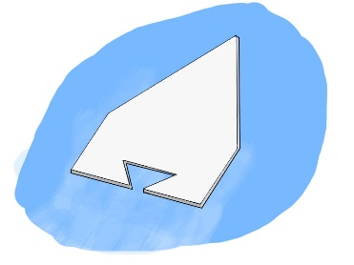

- Make homemade bath bombs, now the ingredients for these are harder to find, but if you can it’s a nice activity. There are loads of recipes out there, here is just one https://www.redtedart.com/bath-bombs-recipe-gifts-kids-can-make/. When you’re done and it’s bath time, plop on in the water and watch what happens.
- Make poop! Model the whole of the digestive system. This video shows you how https://www.youtube.com/watch?v=7av19YhNkhE. I love this one, though it split a class full of 8-year-old boys last time I did it.
- Fill a bath or the sink. What sinks, what floats? What happens to the level of the water when you drop things in?

Design and build:
- Make a blanket fort. Sit in it and make shadows. Then evaluate your fort, what went well? How could you make it better, how could you make it darker or more stable? Ok, now try those improvements.
- Select a victim from your toy box (make sure it is not your best toy and that is not breakable). Ask an adult if they have any spare material and if you can raid the recycling bin. Design and make a parachute – you could make it a competition if you have brothers or sisters. Tie the parachute to your victim, I mean, toy. Ask an adult to drop it from the highest window you have into the garden (or down the stairs). Time it. How did you do? What worked well and what could you do better next time (remember the longer it takes to fall, the less likely your toy is to be seriously injured)? You could always try again… If you (and your adult) are feeling brave you could try this with an egg instead of your toy.
- Build a bridge from any recycling or newspapers you can find. Give yourself a time limit. How much weight can it hold (you can measure this in books or tin cans etc.). Ok, you know the drill by now… what went well, what could you do to make it stronger next time?
- Deign and build a raft from anything you can find (and have permission to use) in the house (yes Stingrays, I know you guys have done this before). Fill the bath or sink with water. Test your raft, does it float? Will it hold one of your toys? Again, what went well, what would make it even better?
- Build a homemade marble run. Did it work? Why / why not?
- Build a tower of lolly sticks or spaghetti and marshmallows or straws and tape. How high can you make your tower? Now choose one of the other ways to make a tower, which one was best?
- Love Star Wars, there are some lovely Star Wars themed design tasks here: https://leftbraincraftbrain.com/star-wars-steam-challenges-for-kids/
- Make paper aeroplanes. Try different designs, which flies straightest, which flies furthest?

Science with toys:
- Make a ramp from cardboard. Take a toy car and send it down the ramp. Change the height of the ramp, measuring how far the car goes each time. What happens as the ramp gets higher?
- Use a pull back car to test friction. Test how far the car will go on different surface eg. carpet, laminate, tin foil, a blanket etc.
- Have a bouncy ball? What affects how high it bounces? Try dropping it from different heights or dropping it onto different surfaces. Only change one thing though or it won’t be a fair test.
- If you have some toy animals, junk model them a habitat.
- Lego is awesome, google some Lego STEM challenges – there are so many ideas.
- Have a yo-yo? What happens if you wrap some of the string around your finger? What happens if you throw it down harder?
- Make a gyrocopter to play with. What happens if you change the length of the wings? What if you add a paper clip or two to the bottom?

Challenge:
- You all know how much I love a science song. If you’re feeling brave write your own – We’d love to post your songs on the website, if you get your parents to send them to us.
- Stingrays asked if they could do a pizza experiment – so if you can design a sensible experiment involving pizza, I will try my best to make it happen.
- If you are feeling like being pushed a little there are some write-up sheets that you can have a go at (you could always just do the prediction, results and conclusion if you want slightly less of a challenge).

Investigations

My question / what I am investigating (how A affect will B): ………………………………………………
……………………………………………………………………………………………………………………………………………….
………………………………………………………………………………………………………………….……………………………

Prediction (What I think will happen): ……………………………………………………………………………….
….……………………………………………………………………………………………………………………………………….
..…………………………………………………………………………………………………………………………………………

Diagram:

Results:

Conclusion (what happened/ was I right or wrong): ……………………………………………………………
……………………………………………………………………………………………………………………………………………..
……………………………………………………………………………………………………………………………………………..

Evaluation:

What went well (was it a fair test?) ……………………………………………………………………………………..
……………………………………………………………………………………………………………………………………………….
……………………………………………………………………………………………………………………………………………….

How I could make it better / more of a fair test …………………………………………………………………..
………………………………………………………………………………………………………………………………………………
………………………………………………………………………………………………………………………………………………

Design Tasks

What I’m making: …………………………………………………………………………………………………………………

My design (draw and label):

Any changes I made once I built it: ………………………………………………………….……………………………
……………………………………………………………………………………………………………………………………………….

What happened: ………………………………………………………………………………………………………………….
……………………………………………………………………………………………………………………………………………….
What went well: ……………………………………………………………………………………………………………………
……………………………………………………………………………………………………………………………………………….
……………………………………………………………………………………………………………………………………………….
To make it even better, next time I would: …………………………………………………………………………..
……………………………………………………………………………………………………………………………………………….
………………………………………………………………………………………………………………………………………………

